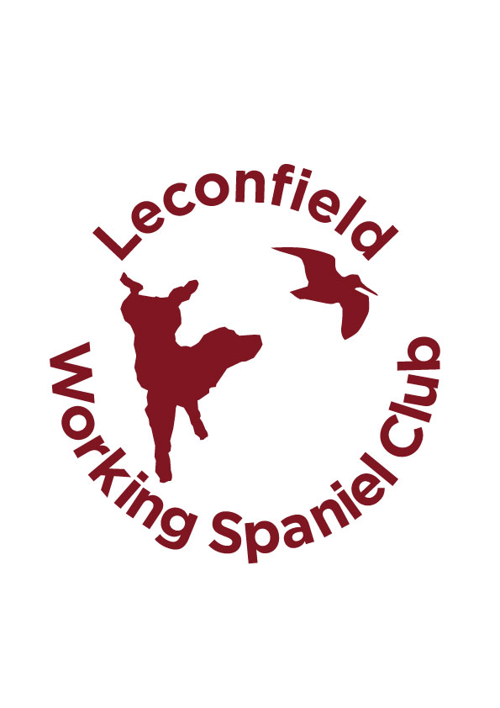
Leconfield Working Spaniel Club
Open Spaniel Stake (excluding Cockers)
15th November 2018
At Peppering Shoot Duke of Norfolk Estate West Sussex

1st Place Willowsaul Joker Andy Waterhouse
2nd Place Murrayeden Brandi Andy Skinner and Guns Choice
3rd Place Wrenmarsh Temptation Mark Watson
4th Place Belvden Justin Time Mark Clifford
COM Buccleuch Quince Tina Nicolas
COM Palmarrion Future Gerry Meehan
COM Ftch Surefly Sassy Terri Siwek
COM Edwardiana Riot Linden Jones

Congratulations to the Winner and all in the awards . Brilliant trial and Judges said not much between all in the awards.Wonderful ground with great atmosphere.

Thank you to everyone taking part and helping you all made the day a great success. The cakes were delicious!!!!

Thank you to to BASC for being the very kind sponsor and our wonderful photographer Rosemary Sadler.

